Customer Shopping Behavior Analysis Report
1. Introduction
This report presents an end-to-end analysis of customer shopping behavior using transactional, demographic, and behavioral data. The objective of this project is to uncover meaningful insights related to customer demographics, purchasing patterns, subscription behavior, and product performance, and to present these insights through a clean, executive-ready Power BI dashboard.
The project follows a complete data analytics workflow, including data cleaning and feature engineering in Python, data storage and querying in SQL Server, and visualization and storytelling in Power BI.

2. Data Overview
The dataset contains customer-level shopping data with attributes such as:
- Customer demographics (age, gender)
- Purchase information (purchase amount, product category, item purchased)
- Behavioral indicators (subscription status, discount usage, purchase frequency)
- Customer history (previous purchases, review ratings)
The raw data was provided in CSV format and required preprocessing before analysis.

3. Data Preparation & Cleaning (Python)
Python (Pandas) was used to clean and prepare the dataset prior to analysis.
3.1 Initial Exploration
- Inspected data structure using info() and describe()
- Identified missing values and inconsistent column naming
3.2 Handling Missing Values
- Missing review ratings were imputed using the median review rating within each product category, preserving category-level sentiment patterns
3.3 Standardization
- Column names were converted to lowercase and formatted with underscores for SQL and BI compatibility
- Renamed ambiguous fields (e.g., purchase_amount_(usd) → purchase_amount)
3.4 Feature Engineering
- Created age_group using quantile-based segmentation (Young Adult, Adult, Middle-aged, Senior)
- Converted categorical purchase frequency into a numeric metric (purchase_frequency_days) to enable aggregation and comparison
- Identified and removed redundant fields (promo_code_used) after validating equivalence with discount_applied
3.5 Data Loading
- Loaded the cleaned dataset into Microsoft SQL Server using SQLAlchemy and pyodbc
- Created a single fact table optimized for analytical queries and Power BI reporting

4. SQL Analysis
SQL was used to answer key business questions and validate insights before visualization.
Key analyses included:
- Revenue comparison by gender
- Spending behavior of customers using discounts
- Top-rated products by average review rating
- Purchase behavior across shipping types
- Subscription impact on average spend and total revenue
- Discount usage rate by product
- Customer loyalty segmentation (New, Returning, Loyal)
- Top products within each category
- Relationship between repeat purchases and subscription status
- Revenue contribution by age group
These queries provided the foundation for the Power BI dashboard metrics and visuals.

5. Power BI Dashboard Design
An interactive Power BI dashboard was developed to communicate insights effectively to stakeholders.
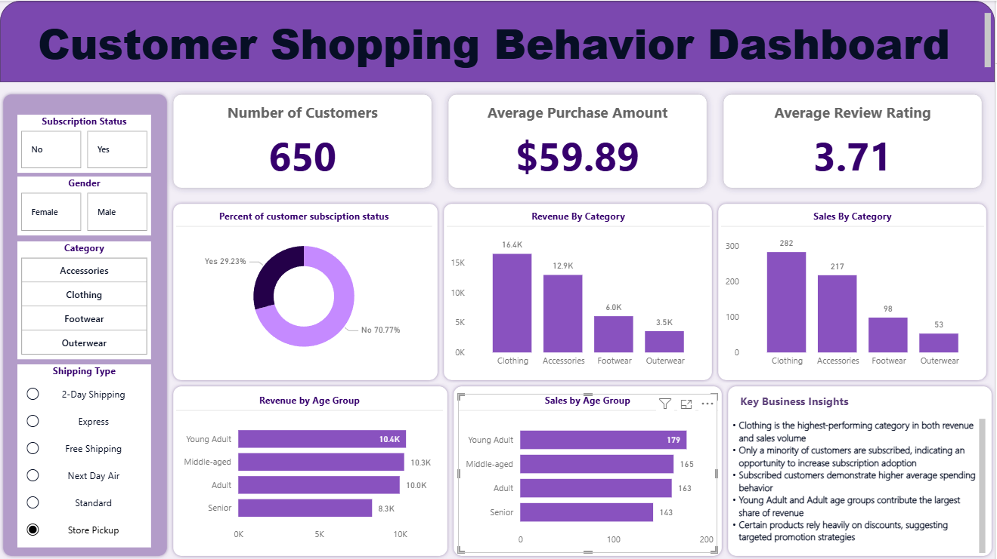
5.1 Design Principles
- Clean, minimal layout with reduced visual noise
- Consistent color palette optimized for data readability
- Clear visual hierarchy (KPIs → trends → insights)
- Business-focused titles and annotations
5.2 Key Dashboard Components
- KPI cards: Total Customers, Average Order Value, Average Rating
- Customer segmentation by age group and subscription status
- Revenue and sales analysis by product category
- Discount and promotion behavior insights
- Key insights panel summarizing actionable findings

6. Key Insights
- Clothing is the highest-performing category in both revenue and sales volume
- Only a minority of customers are subscribed, indicating an opportunity to increase subscription adoption
- Subscribed customers demonstrate higher average spending behavior
- Young Adult and Adult age groups contribute the largest share of revenue
- Certain products rely heavily on discounts, suggesting targeted promotion strategies

7. Business Recommendations
- Introduce targeted subscription incentives for high-frequency and repeat buyers
- Focus marketing efforts on top-performing categories while testing promotions for underperforming products
- Leverage age-based segmentation to personalize campaigns
- Review discount strategies to protect revenue while maintaining customer engagement

8. Conclusion
This project demonstrates a complete data analytics pipeline, from raw data preparation to actionable insights delivered through an executive-ready dashboard. By combining Python, SQL, and Power BI, the analysis provides a scalable and repeatable approach to understanding customer behavior and supporting data-driven decision-making.

9. Tools & Technologies
- Python (Pandas)
- SQL Server
- Power BI
- SQLAlchemy, pyodbc

